

BCW, JAFZA One , Tower A , 11th Floor Jebel Ali Free Zone , Dubai, UAE - P.O. Box 35608

[www.lumytic.com](https://lumytic.com/)

[info@lumytic.com](mailto:%20info@lumytic.com)

**Help Portal**

# Administration

managing and overseeing various aspects of the system to ensure its smooth operation and optimal performance. This includes features such as user management. Effective administration is crucial for maintaining data integrity, controlling access permissions, and customizing the system to align with the organization's needs.

## Employees and Users

### Create User

1. From the Employees page, click **Add**.
2. Enter the employee details and click Save.
3. Open the employee’s details page, click the corner menu button, and select **Create Account.**
4. The user will receive their credentials via email.

 Note

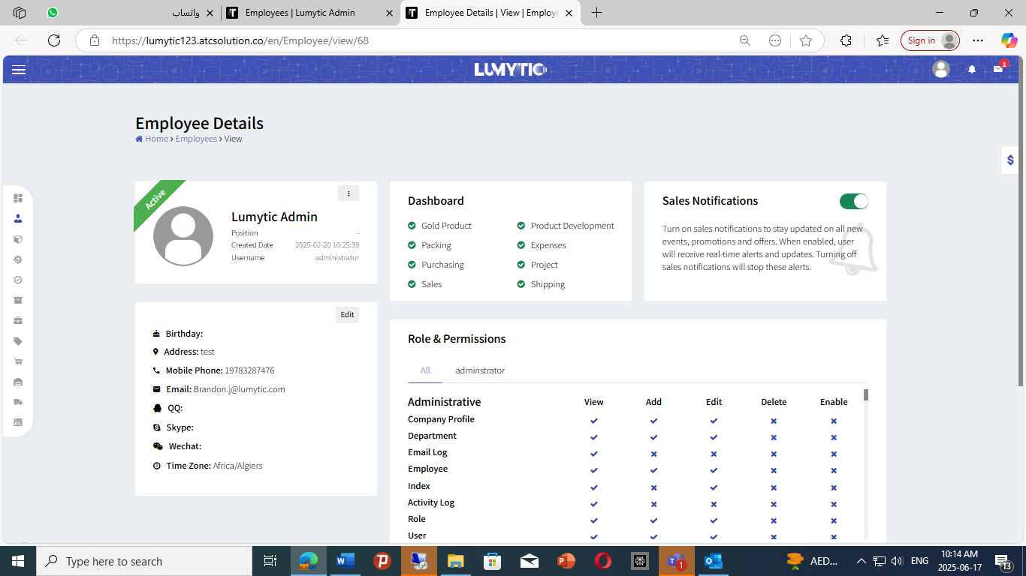The seat strategy followed to add user in Lumytic is superior to the usage-based way as it provides fixed costs, guaranteed access for all assigned users

### Swap Reserved Seat

1. Go to user page
2. From action dropdown set the user status as **Inactive**.
3. Follow the same steps as outlined previously of **Create User**

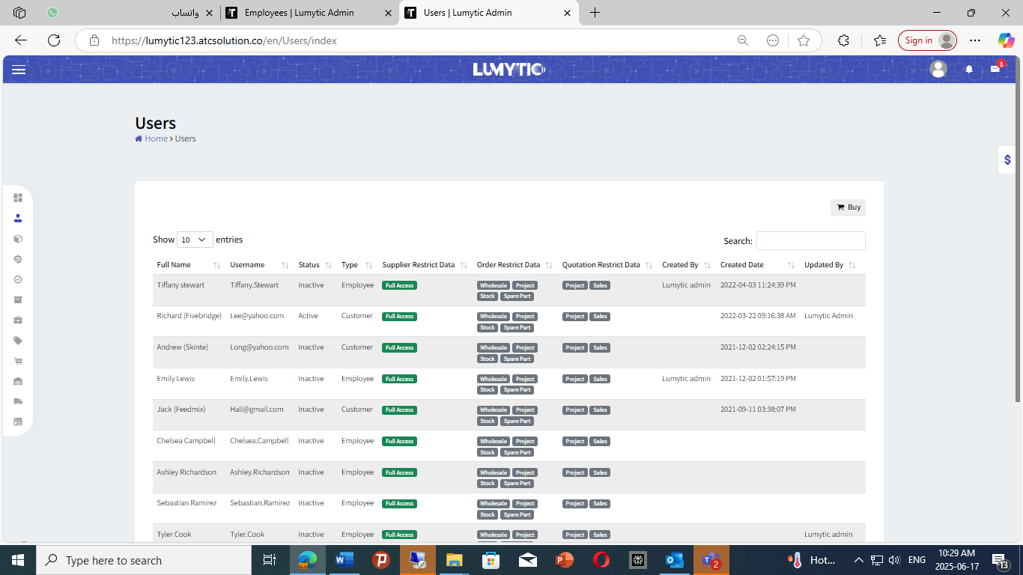

## Dashboard Control

### Edit dashboard

* 1. From **Department** page, click **Add**.
  2. Enter the name of the department

1. Select a dashboard that best suits the needs of your business.

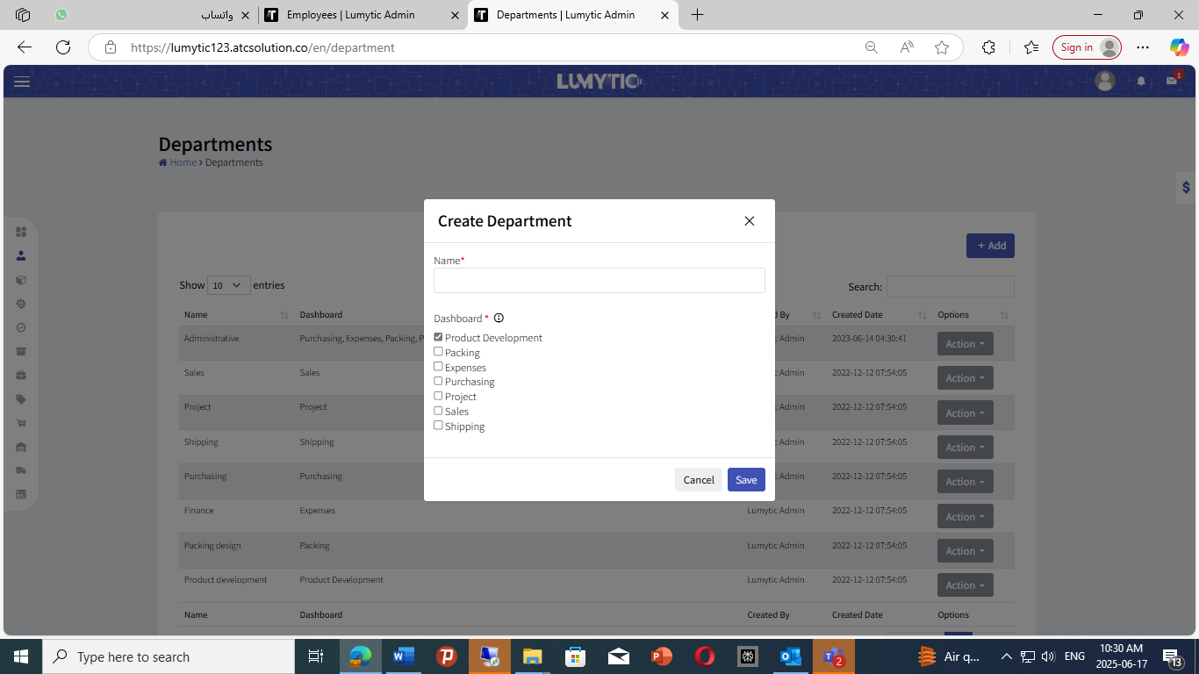

## Company Profile

Define and manage multiple brands for your company within the Lumytic system

### Edit company profile

* 1. From **Company Profiles** page, click **Add**.
  2. Enter the details and save it

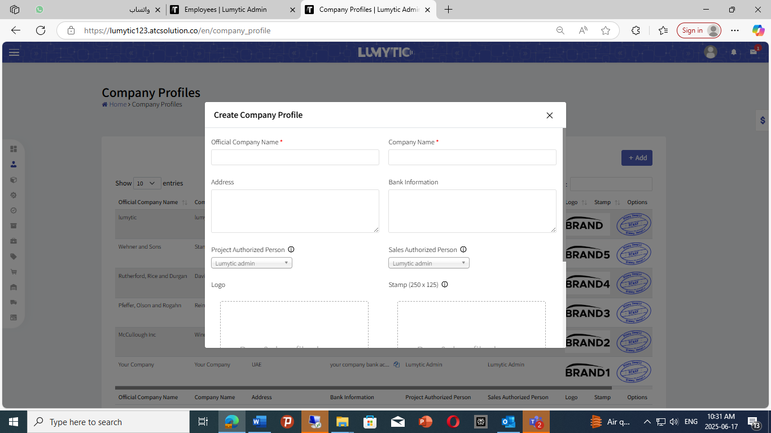

## Indexes

Indexes act as reference points that connect each attribute with its translations and icons, making it faster and easier to manage multilingual content and visual elements for lighting product attributes in Lumytic system

1.4.1 Update Indexes

1. From **Indexes** page, click **Action**
2. **Upload** logo for attribute and **save**



Note   
You can add multiple translations to each attribute for broader language support.

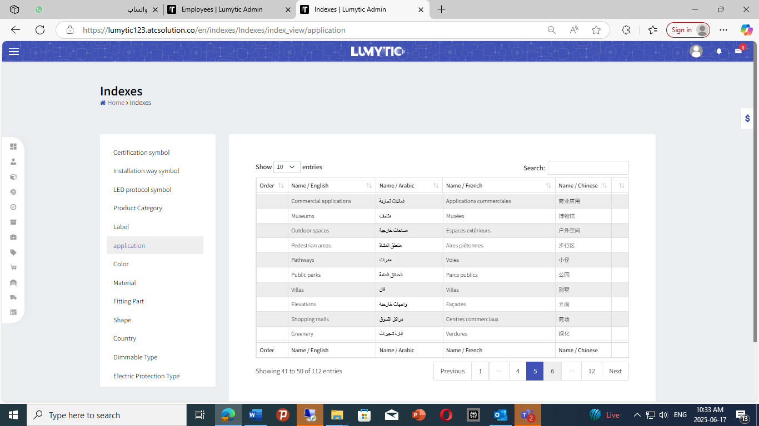

## Role & Permission

Role and permission settings serve as clear reference points that link each employee to their assigned access levels—streamlining user management directly from the employee details page.  
1.5.1 Add the permission

1. From **Role** page, click **Add**.
2. Enter the role name, description, statues then click **Save**.
3. Go to **Role Details Page**
4. From role permission section click **Edit**
5. Add the permission you want to assign then click save
6. 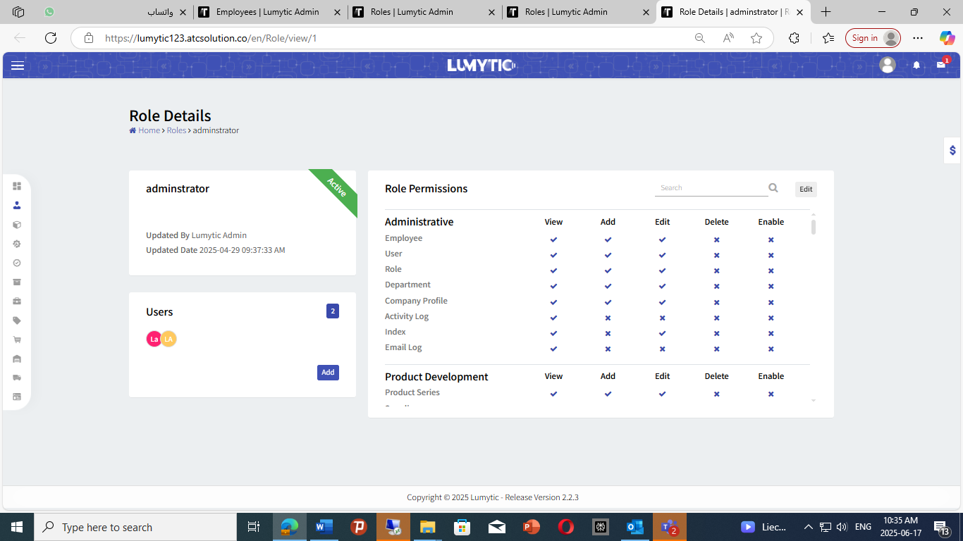Add employee that go with this role

Note

Easily view the assigned roles and permissions for each employee directly from their details page

# Product Development

Seamlessly manages the entire lifecycle of your lighting products, from raw materials to final products. This includes features such as assigning different product code formats, accessing high-level dashboards, and exporting product datasheets. Additionally, the inclusion of supplier profiles enhances supply chain management

## Supplier

### Add new supplier

Managing suppliers in Lumytic helps maintain accurate records, strengthens business

relationships, and enables streamlined operations and rapid access to suppliers.

1. From **Dashboard** open **Product Development app.**
2. Select **Suppliers**, click **Add**.
3. **Enter** the supplier’s basic information Official company name, company name, commercial registration number commercial Registration file
4. Supplier code, Website, Adress, and logo click **save.**

### Create Contact

1. From **Supplier Details** **Page** click **Add**
2. Enter full name, Position, Currency and other contact details like phone number and email then click **Save**.

### Add Bank Details

* 1. From **Supplier Details Page** on **Bank Details** section click **Add.**
  2. Enter the **beneficiary’s name** as registered with their bank.
  3. Provide the **bank name, branch details, SWIFT code, and bank address**

Select the transaction **currency**, ensuring it aligns with the agreed terms then click **Save.**

### Set visibility to Public.

* + 1. Navigate to the Supplier Details page.
    2. 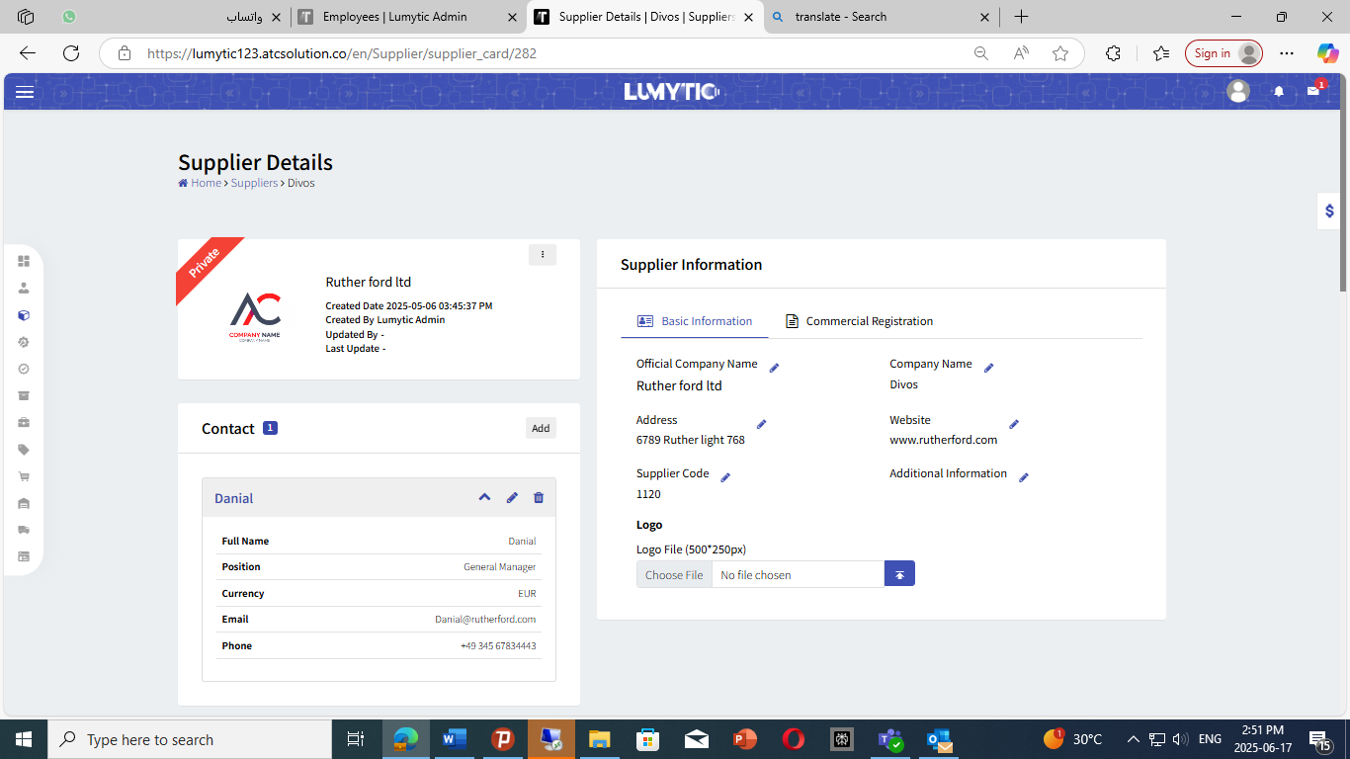click the corner menu button, and Set Supplier to Public, **then** clickyes.

## Component

Users have the capability to add various lighting components, including LEDs, Drivers, Solar System devices, Accessory to the system.

### LEDs

1. From **LEDs** page, click **Add**.
2. Select the appropriate **Lighting Source** and its type.
3. Choose the **Supplier** from the dropdown list and provide the **supplier's code**, and **Cost**, then click **Save**

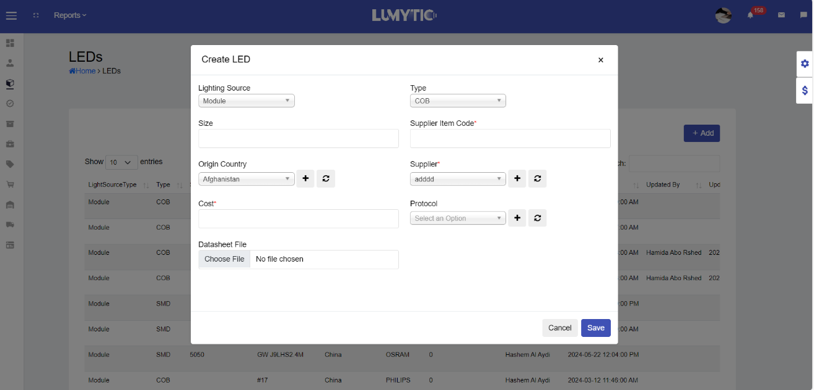

### Drivers

* + - 1. From the **Drivers** page, click **Add**.
      2. Select the appropriate **Power Source** and **Output Type.**
      3. Enter **the Power and Frequency value,** choose the **Supplier** from the dropdown list
      4. Provide the **Cost,** then click **Save**

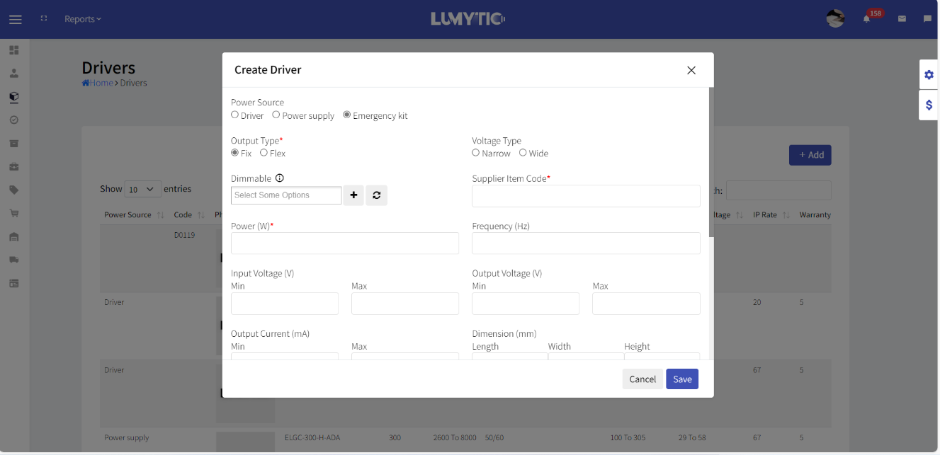

### Solar Lighting Systems

* + - * 1. From **Solar Lighting Systems** page, click **Add**.
        2. Enter the **Cost** and **Supplier Item Code**, select the **Supplier** from the dropdown list.
        3. provide a detailed **Panel** such as Power, Type, and Output voltage.
        4. Enter **Battery details** including **input voltage.**
        5. Choose the **Supplier** from the dropdown list and provide the supplier's code, then click **Save**

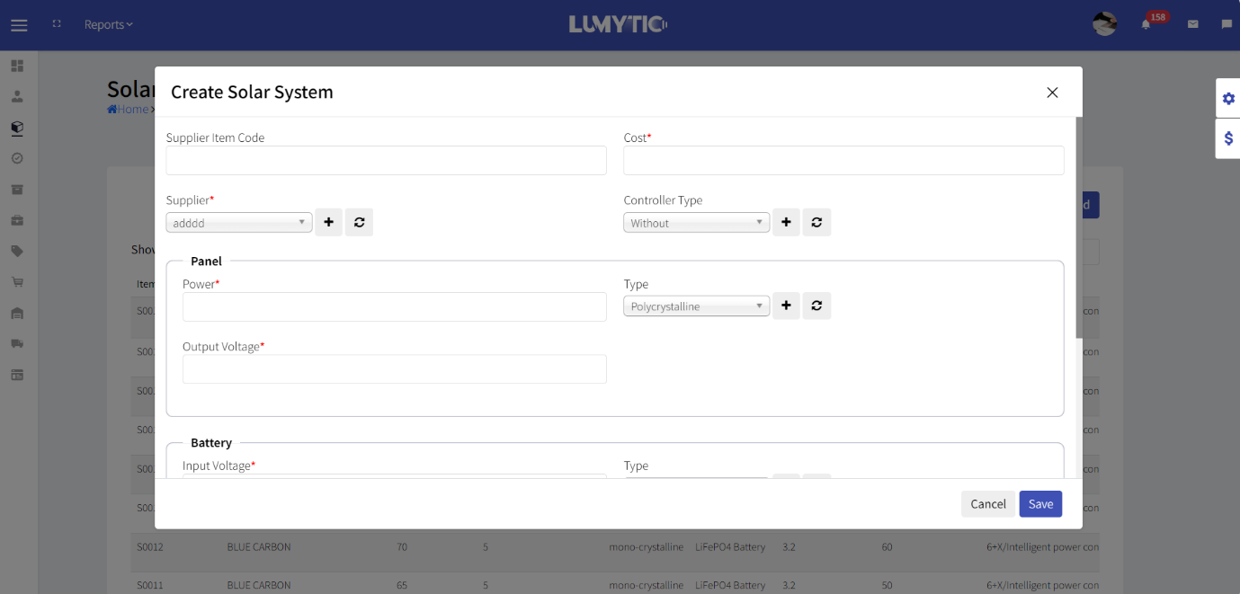

### Accessory

From **Accessory** page, click Add.

Enter the **Cost** and **Reference Code**, select the **Supplier** from the dropdown list, and provide

a detailed **Description** for the item.

click **Save**

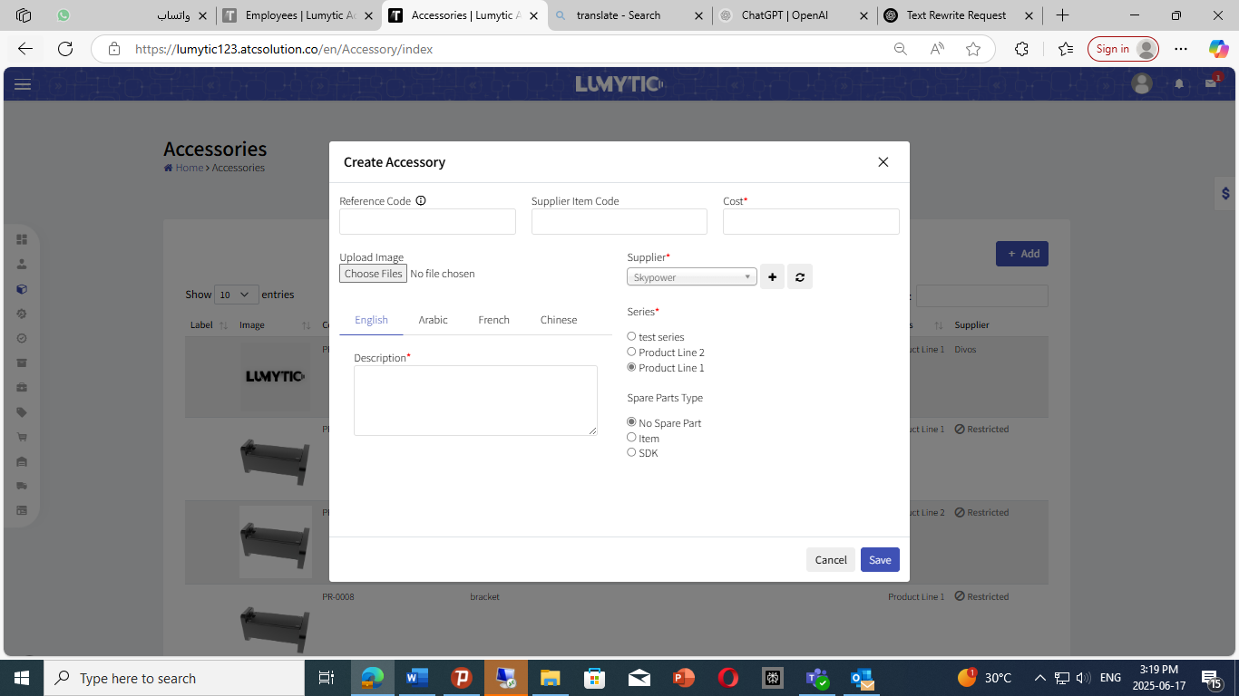

## General Products

From **General products** page, click Add.

Enter the **Product Type**, select the Supplier from the dropdown list

Provide a detailed **Description** for the item the, click **Save**

## Product Series

### 2.4.1 Edit product series

From product Series Page, click **Add**

Enter the series **name**, upload product series catalog file.

### 2.4.2 Upload product series catalog file

From product Series Details Page, click **Add** to create catalog file

Enter **name**, upload cover and catalog file, then click save.

### 2.4.3 Upload product series catalog file

### 2.4.4 fill Product Config

Select the appropriate **Product Type** , and choose the **Coding Format**.

Then, select the relevant **Datasheet Template**

Enter a **Unique Shortcut Code** to simplify future reference, then click **Save**

### 2.4.2 Upload product series catalog file

From product Series Details Page, click **Add** to create catalog file

Enter **name**, upload cover and catalog file, then click save.

### Upload product series attachment file.

From product Series Details Page, click **edit** attachment file

Review the available **types** and select any of them you wish to include by checking the corresponding boxes.  
You can modify **attachment files** at any level Product, Family, or Dimension as needed.

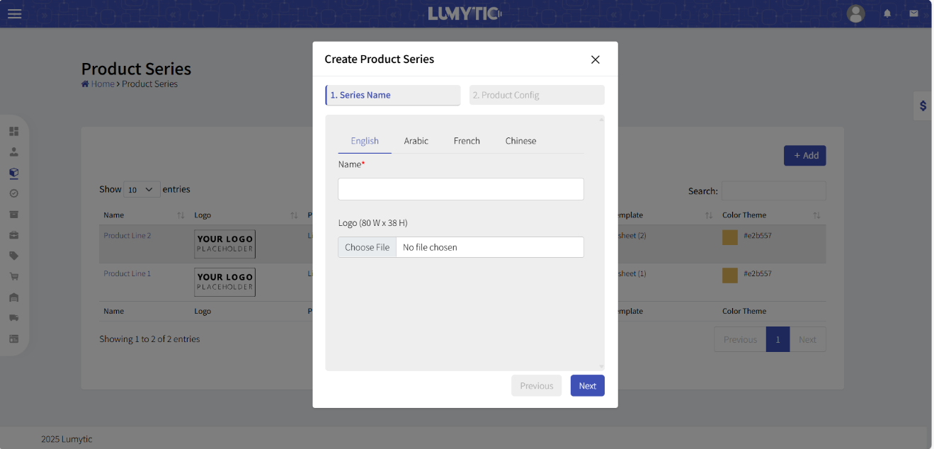

### Sort product family

1. From the family details page click on order family to **sort**
2. drag and drop to change family display order then, click **Sa****ve**

## Product family

The Product Family groups lighting products that share similar specifications or features relevant to their market and operations

From **Products Family Page**, click on **Add**.

Enter the **family name**, description, and a **shortcut**, which will serve as the base for product coding, then click **Save**

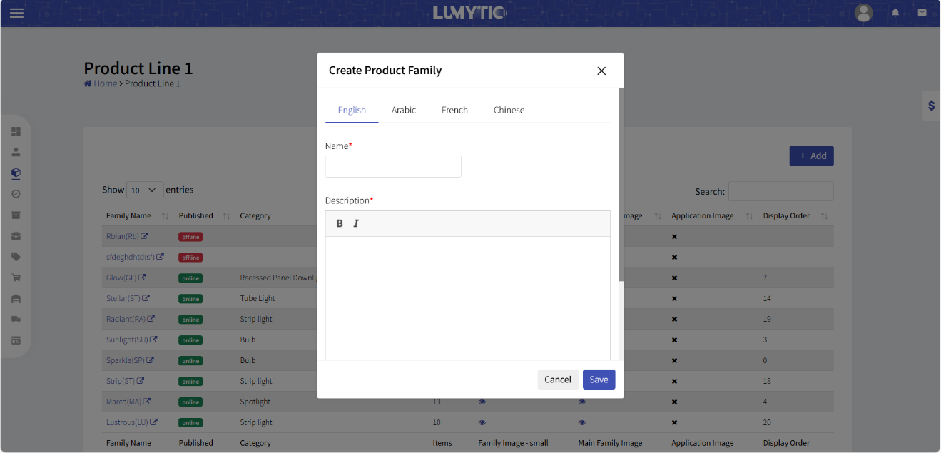



Note

Easily generate datasheet list for the products family from the **Family Details** page click on

**Print Datasheet List** to instantly create a professional, ready-to-use datasheet list

## Product Management

Create a single product by filling in lighting attributes which have been studied by lighting experts.

### 2.6.1 Add single [Product](https://lumytic123.atcsolution.co/en/Product_series#wizard-h-1)

1. From **Product Family Details** page, click **[Add single Product]**
2. Fill in basic product information like, **Manufacturing Technique**, **Product** **Status**, and **Category**. Specify **installation way**, select **origin country**, and the **Powering Mode**
3. Next, provide detailed product **Dimensions**, **Supplier Name**, and Additional Information such as **lifespan**, **warranty**, **IP rate**, **UGR**, and **beam angle**.
4. Move on to the Fixture tab to specify **power**, **voltage**, **lumen** **output**, **dimming types**, **CCT,** and **CRI**. Don’t forget to add, **cost**, and any **battery** and **charging info**. Finally, upload necessary files and select compatible accessories, then click **Save**

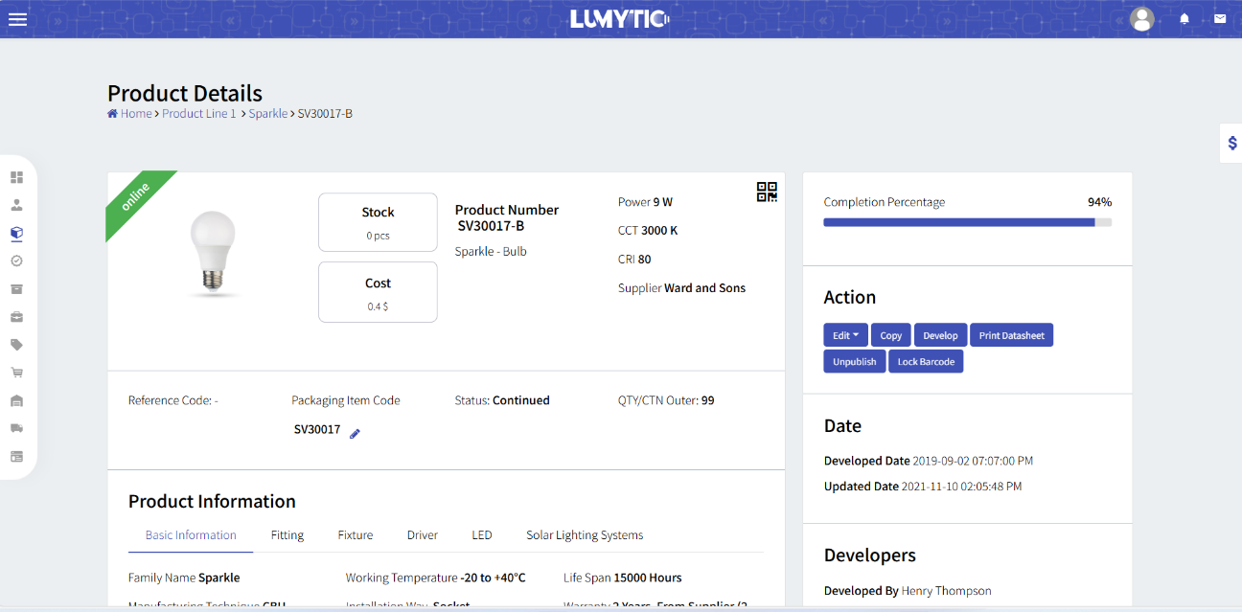

** Note

Easily Generate product datasheet to give a professional touch to your business from the **Product Details Page** click on **Print Datasheet** to instantly create a professional, ready-to-use datasheet

### Add Product Via Mixer

The Lumytic Mixer leverages advanced technology to effortlessly generate set of products based on key attributes like power, CCT, CRI, beam angle and more. Just In a single click, you can create a complete range of options, which saves your effort and time.

1. From Product Family Details page, select **Add Product** via mixer.
2. **Fill** in basic product information, as specified in the Single Product.
3. Next, **navigate** to the Fitting tab and select a fixture. Complete all required fields as outlined in the **[single Product]** section.
4. Easily generate a professional product datasheet from the **Product Details** page. To begin, you must first add the product by clicking the **[Add Product]**and completing all required fields as specified in the Single Product section In the Mixer tab, define the base lumen values for each power level based on specific CCT (Correlated Color Temperature) and CRI (Color Rendering Index). These values serve as the reference for the system to automatically calculate lumen output across all generated product configurations.
5. Finally, **upload** the necessary files and click **save.**

### Bulk Action

Bulk Actions allows you to select and perform multiple actions on products, such as Edit, Upload, Publish, or Delete. This feature optimizes workflow, increases productivity, and helps maintain consistency across large product sets.

* + - 1. From the **Product Family Details** Page, click on Bulk Action.
      2. Select the products you wish to apply changes to, then click Next.
      3. Choose the desired action: **Edit**, **Upload**, **Publish**, or **Delete**.
      4. Make the necessary changes based on the action you selected.
      5. Click **Save**

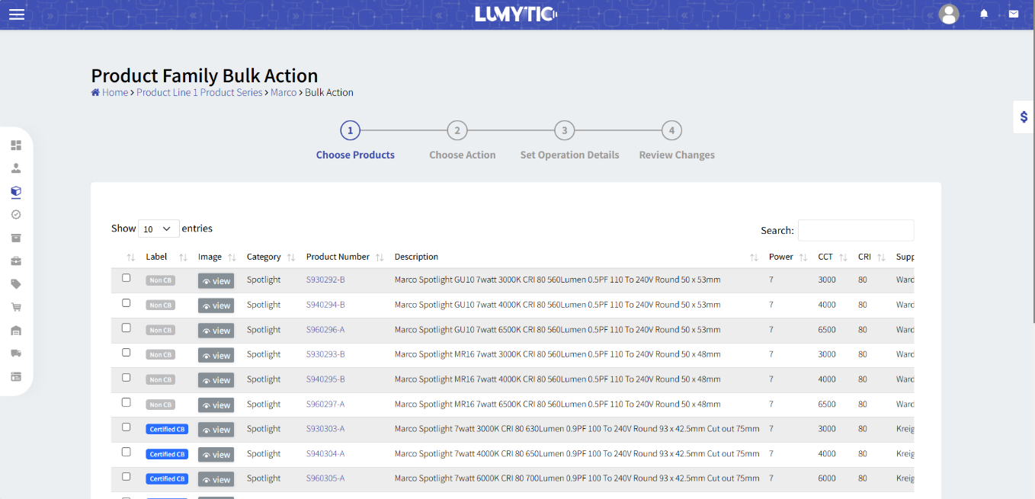

### Product Certification

Product lighting certification refers to a process by which lighting products and systems are tested and certified to ensure their compliance with industry standards and regulations  
2.6.4.1 Insert a certification

1. From the Product Details page, scroll to the Certification section and click **Add**.
2. Select the **Certification Type** and ensure it aligns with global safety standards.
3. Enter the required information, including **Certification Code**, **Owner**, **Issue Date**, **Expiry Date**, and **Class**.
4. Upload the supporting certification file.
5. Click **Save** to complete the process.

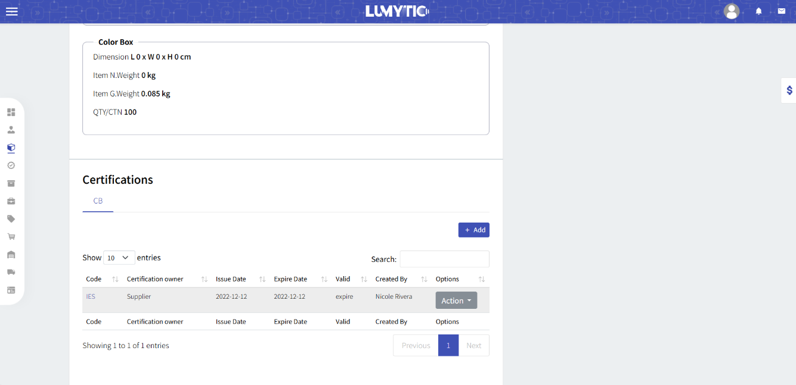

## Product Develop Request

Efficiently develop a range of lighting products with one feature for tracking, collaboration, and comparison to improve your team collaboration and track development cycle.

### Create request:

* + 1. From the Develop Request Page, click **Add Request**.
    2. Select the **Product Solution**, **Category**, and **Family**.
    3. Choose the development level—whether it's for an **Item**, **Dimension**, or **Family**.
    4. Assign the request to an employee, set its **Priority**, and enter the **Title**.
    5. Click Save to finalize the request.

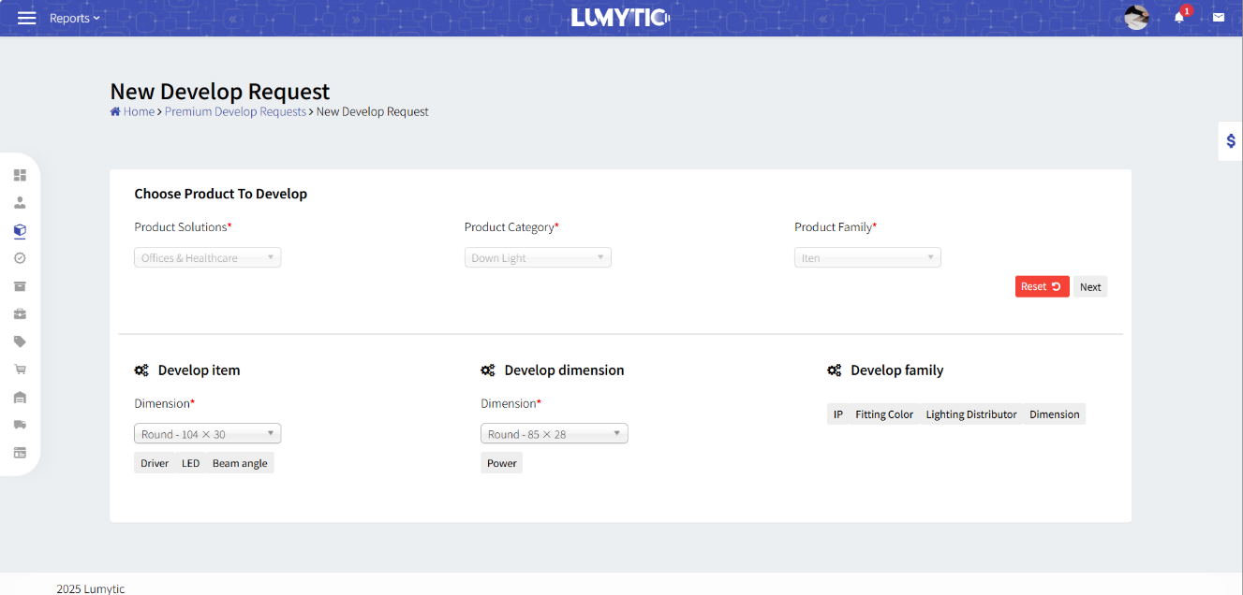

### Create Response

1. From the **Develop Request Page**, click **Add Response**.
2. Review and implement the requested changes.
3. Click **Save** to finalize and submit your response.

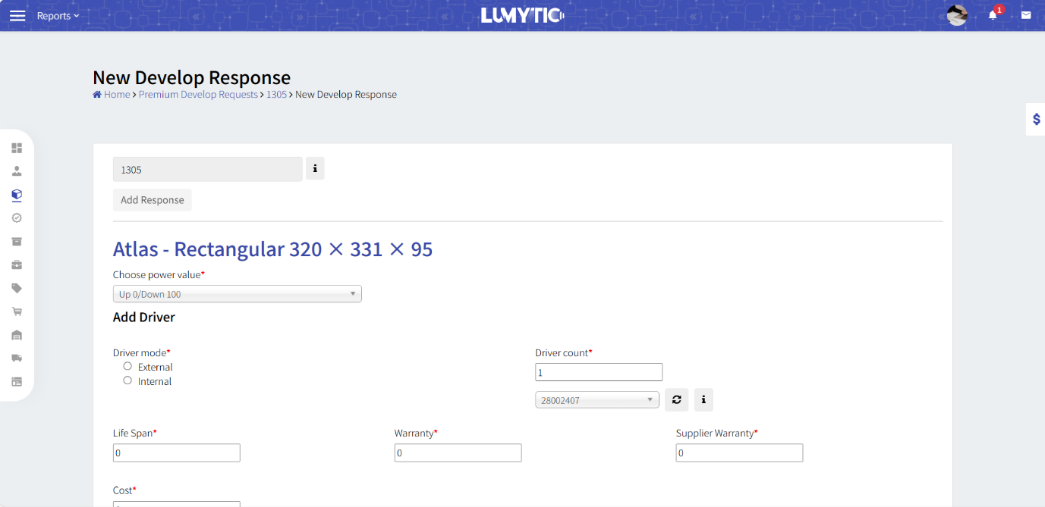

# Sales

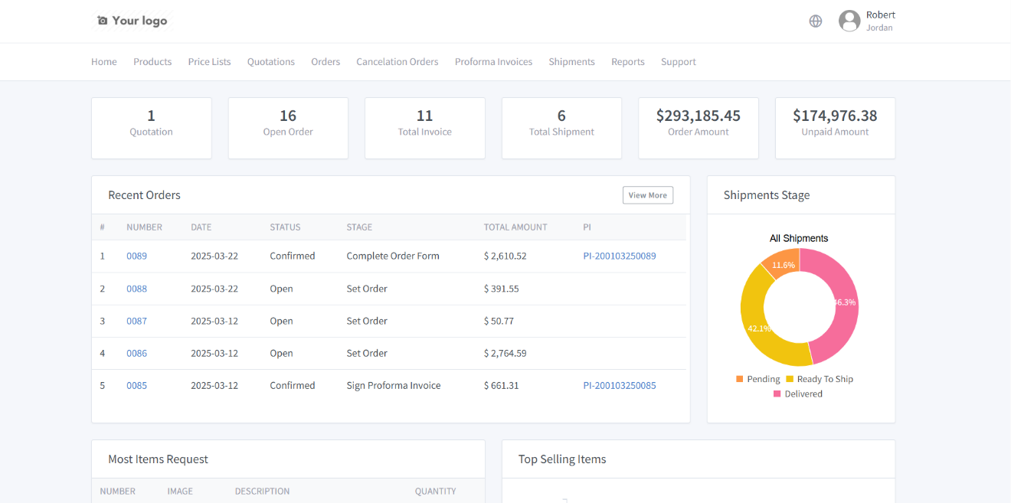The Sales App in Lumytic manages the complete sales workflow from customer registration and quotation generation to order processing, invoice management, and payment confirmation. It enables seamless communication with clients and simplifies the entire sales cycle.

1. From customer page, click add.
2. Fill in: Company Name, Website URL, Country, Email Address, and Country.

## Add customer

Registering a new customer in Lumytic ensures a smooth onboarding experience and accurate customer profile setup.

### 3.1.1 Invite customer

From Customer list, click on invite customer button

Enter the customer's name and email address

The system will send an email to the customer containing a registration link to access the Customer Portal.

### Customer Registration via Portal

1. From Lumytic customer portal login page, **click** sign up button to start the registration process.
2. **Enter** Basic Company Information
3. Fill in: Company Name, Website URL, Country, Contact Person, Email Address, and Physical Address.
4. Fill in: the Shipping and Billing details: First and Last Name, Commercial, Foundation Name, Email Address, Country, Commercial Registration Number and Upload it's the required file.



Note  
If billing is the same as shipping, check the confirmation box.

1. Once all fields are completed, click **Send** to submit your registration request.

Upon **approval**, you will receive an email with your login credentials to access your Lumytic account.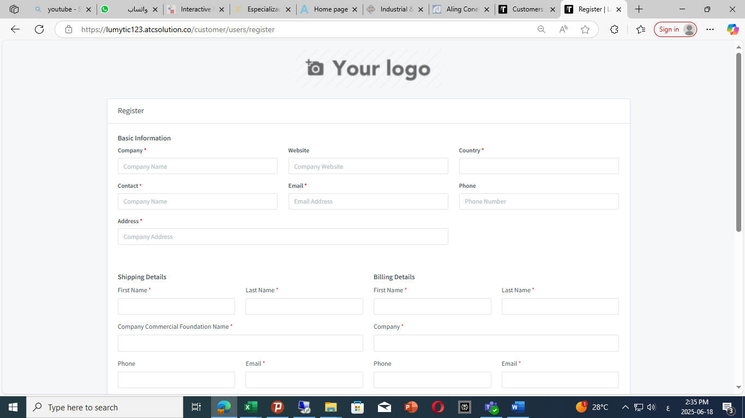

## Quotation

Generate detailed, professional quotations tailored to client needs and Incoterms.

### 3.2.1 Add quotation

* + - * 1. From Sale App, Quotation page, click Add.
        2. Specify required product quantities, click **Next**.
        3. **Provide** Basic Information including:  
            Company Profile, Contact Person, Currency, Customer and it’s Contact Enter the Shipping, Certificate, Clearance and Additional fees  
           Choose Incoterms, **enter** Validity and Delivery Days.

Select **payment** type and define Value and Unit.

Items and quotation summary all information, then click **Save**.

### 3.2.2 Generate quotation

1. From Sales Quotation Details **Page,** click print to **export** professional quotation documents in one click.

### 3.2.3 Share quotation via following link

1. To create a shareable **link,** from Sales Quotation Details page, click the corner menu button, and send the quotation directly to customers

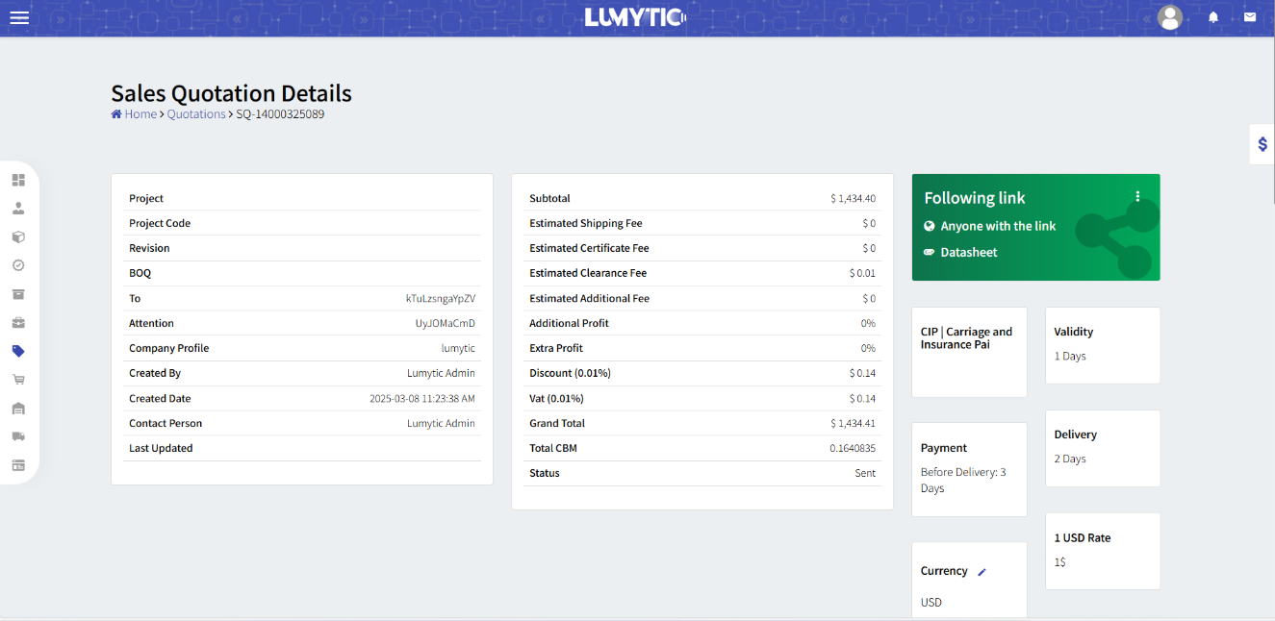



Note

you can Create a shareable link Sales Quotation Details Pageto send the quotation directly to customers.

## Order

Manage and track orders from placement to payment confirmation.

### Create order via Customer Portal

1. From Lumytic customer portal ,navigate to the Orders Page, click **Add** to create a new order.
2. Enter product quantities and review selection click **Next**, then **submit**.

 Note

An email will be sent once each stage has been completed to keep the collaboration on the process.



## Performa Invoice

Generate clear and compliant proforma invoices

### 3.4.1 Add Proforma Invoice

1. From the Order Details Page, Proforma Invoice Section, click **Add.**
2. **Enter** Basic Information.  
   Include Company Profile and Contact Person
3. Move to Terms and Conditions Choose the appropriate incoterms type, **fill** Validity and Delivery Days.  
   Select the payment type and **enter** the corresponding Value and Unit.
4. **Review** item prices and make any necessary changes, then click **Save**.

3.4.2 Confirm Proforma Invoice

1. Confirm Proforma invoice if no edits are required

### 3.4.3 Generate Proforma Invoice

1. Instantly generate professional- looking Proforma invoice from lumytic system, with just one click.
2. Create and manage multiple version of your invoice
3. From Proforma invoice details, click edit
4. Make the necessary **changes** to **Proforma Invoice**

**Confirm** the changes to generate a new version of Proforma Invoice, then click **save**.

1. 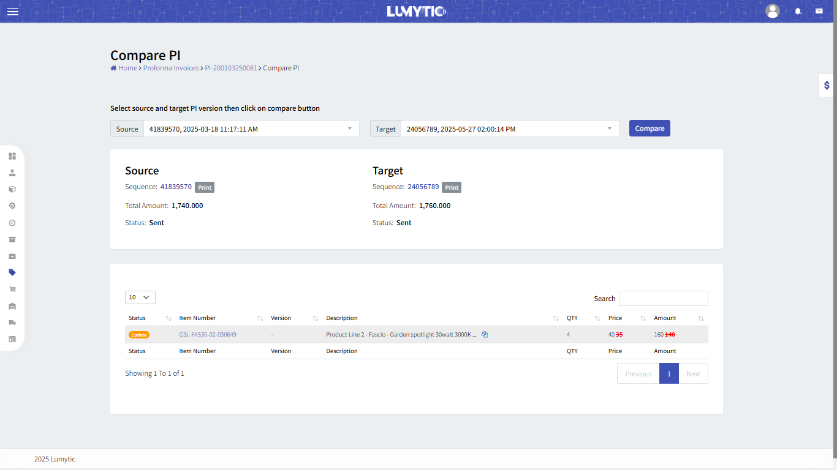**Compare different version of the** Proforma Invoice   
   From Proforma Invoice Details, make change. Then, **compare** between two version, then click **save**.



Note   
An email will be sent once each stage has been completed to keep the collaboration on the process.

**3.4.1 Sign Proforma Invoices**

1. From customer portal page, **click** on upload signed proforma invoice to begin the process.
2. Once the signed proforma invoice is uploaded, from Proforma Invoice Details **click** on **Approve signed File** and **review** order details.
3. **Set** the payment amount and **upload** the bank swift file as proof of payment.  
   Then **Submit** it to **proceed**.
4. **Confirm** the payment and **verify** that all details are in order.

## Price List

Create and manage customized price lists in Lumytic to align with your business strategy and profitability goals.

1. From Sales App, navigate to the **price list** page, Then click **Add.**
2. Generate **Price List**.
3. Review and select available products Enter the desired profit value ,click **Save.**
4. Generate a professional **price list document.**

